­

Blueberries are a common perennial crop in the southeastern US. Blueberries require acidic soil, so the soil must be acidified to 4.5-5.5 pH (Gardner, 2021). This is commonly done with sulfur (Stafne et al., n.d.). Before planting, any hardpans are removed with a subsoiler, and weeds are removed by thorough tilling (Stafne et al., n.d.). Tilling pine bark into the soil at planting to increase organic matter content has been found to make the crop substantially more productive, although fresh wood chips are counterproductive since they trap nitrogen (Stafne et al., n.d.). After the soil mixture is complete, it is pulled into raised rows to protect the roots from overwatering (Stafne et al., n.d.). Blueberries are typically planted between December-February, and can take 2-3 years to produce (Cramer, 2021).

SOIL ORIGINS AND CLASSIFICATION

Gold Boundless Bar

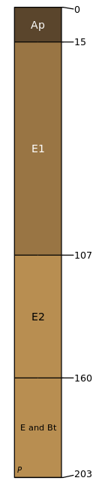

The soil at Southern Hill Farms, a blueberry farm in Lake County, is a member of the Entisol order and Candler series. Candler is a sandy soil primarily made up of silica. Due to its high silica content, 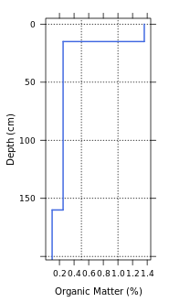quartz is likely a dominant parent material for this soil. The top layer of this soil is 1.4% organic matter and 96.7% sand. This layer is 15cm deep, and has a distinct tillage mark at the bottom. Below this are two layers of porous, often white sand that allow water to trickle through to 160 cm below the surface. The bottom layer of this soil is sand and bedrock, and goes to 203 cm below the surface.

PHYSICAL PROPERTIES OF SOIL

Gold Boundless Bar

Candler soils have a sandy texture. Due to the high amount of sand, candler soils drain quickly and are highly permeable. The topsoil of this series is typically strongly acidic, making the cultivation of blueberries easier. The CEC reading at Southern Hill Farms was 2.4 cmol charge/kg soil in the topsoil, and 1 in the layers below. This is relatively low for soils, and means its ability to retain cations such as calcium and magnesium may be diminished (Mengel & Purdue University Department of Agronomy, 2019).

MICROORGANISMS IN YOUR SOIL

Gold Boundless Bar

Beneficial bacteria called Rhizobia are responsible for converting nitrogen into forms that are useful to plants. Beneficial fungi called mycorrhizae improve plant stress tolerance and growth speed.

How to increase microorganisms:

* These microorganisms mainly eat organic matter – so adding some to the soil will give them more to eat.
* Reducing tillage can allow mycorrhizae networks to develop.
* Cover crops have shown to increase Rhizobia populations.

EFFECT OF CLIMATE CHANGE

Describe the possible effect of climate change on the cropping system and the need for action in your own words.

IRRIGATION

Gold Boundless Bar

Described in detail how your cropping system is typically irrigated. If the plant can be irrigated with multiple ways, then describe that.

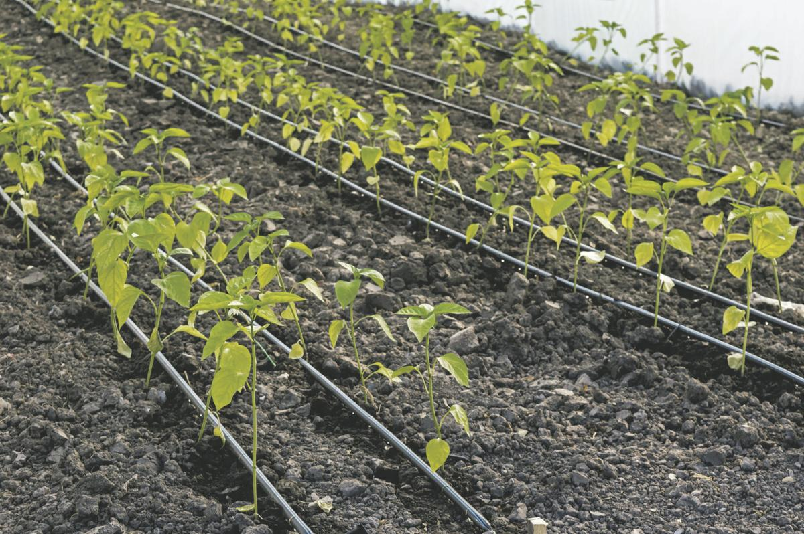

­

WATER NEED AND SCHEDULE

Gold Boundless Bar

Described crop water need based on the time of year/stage of growth. For example, just planted or seedling vs maturity or maintenance for stage of growth AND evapotranspiration rate for time of year. Thoroughly described a generalized watering schedule. This may be written out or put in a table. It should include differences in initial planting and maturity.

KNOWING WHEN TO WATER

Gold Boundless Bar

Thoroughly describe three ways to know when to water/monitor for soil moisture.

SOIL pH

Gold Boundless Bar

Described how to increase or decrease the pH depending on your soil pH and crop needs.

FERTILIZER RECOMMENDATIONS

Provide recommendations for fertilizing the plant including when, where, how much, and what type and the method(s) that are done (broadcasting, sidedressing, banding, etc.)

HOW TO DO A SOIL SAMPLE

Gold Boundless Bar

Described how to do a soil sample for your plant, including how deep to dig, number of samples, areas where the samples should be done, how to collect it, and how to send it.

NUTRIENT DEFICIENCIES

Gold Boundless Bar

Describe at least three nutrient deficiencies that occur on your plant, including a description of symptoms (showing photos of symptoms) and how to correct it.

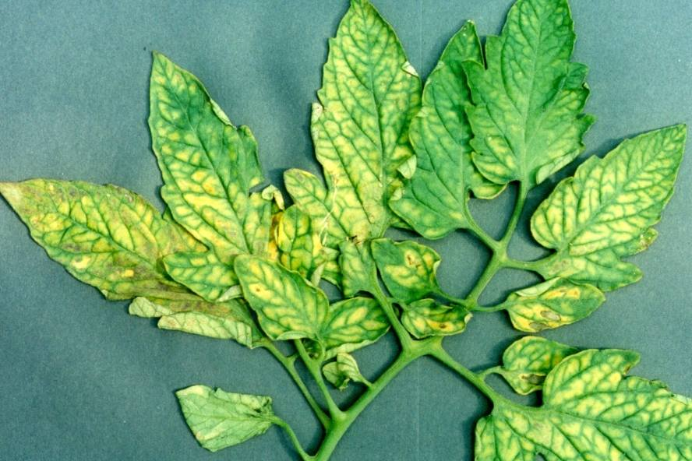

Magnesium deficiency of tomato

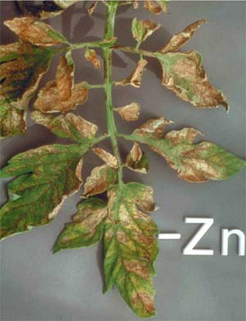

Zinc deficiency of tomato

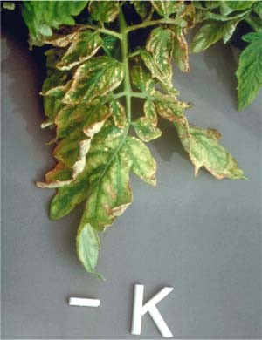

Potassium deficiency of tomato

REFERENCES

Gold Boundless Bar

Cramer, E. (2021, July 6). *How To Grow Blueberries By The Bushel*. Epic Gardening. https://www.epicgardening.com/how-to-grow-blueberries/

Gardner, F. (2021, November 1). *Soil pH For Blueberries: What You Should Know*. Plantgardener. https://www.plantgardener.com/soil-ph-blueberries/

Mengel, D., & Purdue University Department of Agronomy. (2019). *Fundamentals of Soil Cation Exchange Capacity (CEC)*. Purdue.edu. https://www.extension.purdue.edu/extmedia/AY/AY-238.html

Stafne, E., Melanson, R., Layton, B., Silva, J., & Canales, E. (n.d.). *Establishment and Maintenance of Blueberries | Mississippi State University Extension Service*. Extension.msstate.edu. Retrieved August 28, 2022, from https://extension.msstate.edu/publications/publications/establishment-and-maintenance-blueberries

‌UC Davis California Soil Resource Lab. (2021, Nov). SoilWeb https://casoilresource.lawr.ucdavis.edu/gmap/

‌

‌